THE KNOCKDUFF STONE AXE
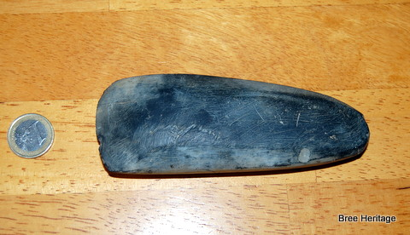
This beautiful example of a stone axe was found by Nim Dunne and his son Pat on their land in Knockduff, Bree (see map below). The axe represents the oldest artefact ever found in the parish and it is broadly contemporary with the iconic portal tomb/dolmen located in Ballybrittas townland. The axe, which was probably originally held in wooden haft, would have been an essential tool for our prehistoric ancestors, being used for a wide range of carpentry activities. Although stone axes were used since the earliest phase of human settlement in Ireland (c. 7000 BC) they are generally seen as one of the characteristic artefact types of the Neolithic period (4000-2500BC).
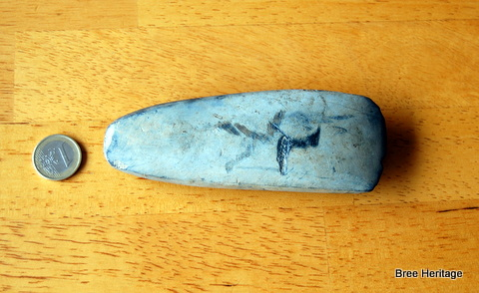
The Neolithic saw the first farmers land in Ireland and these new arrivals quickly set about clearing the country’s extensive forests with axes similar to the one found at Knockduff. On this newly opened farmland they grew crops such emmer wheat and barley and raised domesticated animals such as cows, sheep and goats. They lived in large wooden houses, similar to the one recently excavated at Dunsinane, in Davidstown (see map below). These Neolithic buildings were generally rectangular in plan, with sturdy walls made out of posts and planks and roofs that were thatched in straw or reeds. Large amounts of timber would have been used in their construction and this material would have been cut and fashioned with stone axes similar to the Knockduff example.
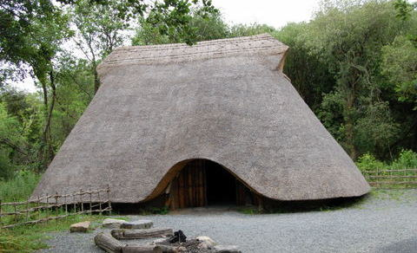Neolithic house at the Heritage Park in Wexford
The people who lived in these Neolithic houses were often buried in megalithic tombs, such as the one found in Ballybrittas townland on the lower slopes of Bree Hill (see map below). This portal tomb or dolmen would have been the final resting place for the parish’s very first farmers. Is it possible that the person who dropped the Knockduff axe nearly 6,000 years ago, is buried here?
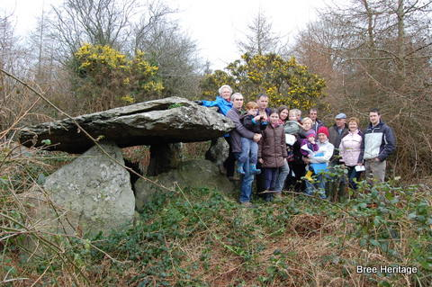Ballybrittas Portal Tomb
Although this question will remain unanswered the significance of the Knockduff axe to our parish’s heritage is beyond doubt. Thanks to Nim and Pat Dunne for bringing their important discovery to the attention of the Bree Heritage Group and also the National Museum of Ireland. This is only the 17threcorded axe from County Wexford[i].
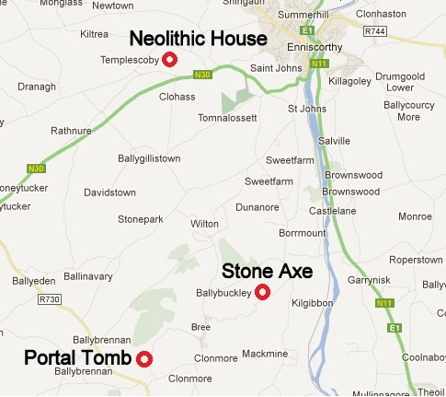Locations of sites mentioned
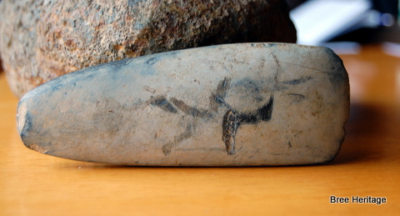

[i] Cooney, G. & Mandal S. (1998) The Irish Stone Axe Project. Monograph I. Wordwell. Bray.

